**WRB Excursion – Peru 2025.**

**Titicaca Lake to Amazon soil catena**

First Circular – March 2024

**Dates**

* Arrival to Juliaca airport. **Sunday 10 august 2025** (to be arranged by each participant)
* Field trip. **Monday 11 august 2025 to Saturday 16 august 2025** (bus)
* Departure from Juliaca airport **Sunday 17 august 2025**

**How to arrive to Puno**

From the Jorge Chávez International Airport (LIM) in Lima – Peru you can take a flight to the Inca Manco Cápac International Airport (JUL) in the city of Juliaca.

|  |  |
| --- | --- |
| Aeropuerto Internacional Jorge Chávez (LIM) - Aeropuertos.NET | C:\Users\Juan\AppData\Local\Microsoft\Windows\INetCache\Content.MSO\D1F8B6A5.tmp |
| **Link lima airport:** <https://www.lima-airport.com/> | **Link Juliaca airport:** <https://www.aap.com.pe/sedes/jul> |

From the Inca Manco Cápac airport you can take a tourist or collective transportation (cost 10 to 20 USD) to the city of Puno at the airport exit, which is available upon the arrival of each flight.

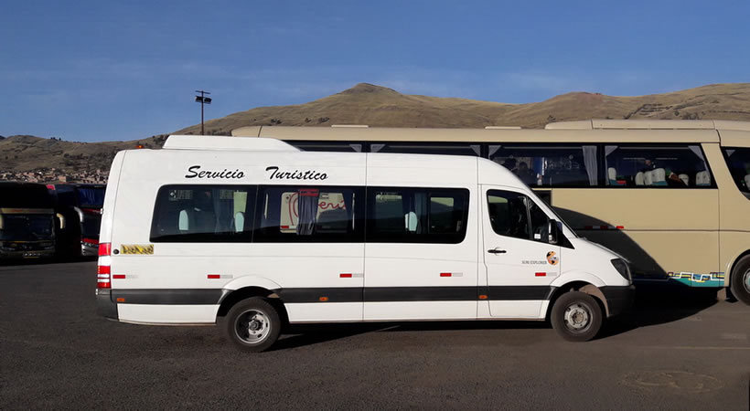

Juliaca Airport shuttle connected to Puno city

**Programme**

The WRB Peru field trip is organized to visit a soil Catena from Puno high plateau (3800 m.a.s.l) to Madre de Dios Region in the Peruvian Amazon Jungle (130 m.a.s.l), from cold and dry high mountains with a glacial landscape nearly to 4900 m.a.s.l. Many soils are formed from glacial, alluvial, colluvial and lacustrine deposits with salts, carbonates and high bases lixiviation processes under variety of climatic conditions from 5ºC to 25 ºC. It is the opportunity to know the Aymara and Quechua prehispanic culture, traditions and monuments in the cradle of the Inca empire and the traditional agriculture ridges Waru Waru and Titicaca lake islands.

The reference soil group will be visited in the excursion include Umbrisols, Regosol, Cambisol, Alisol, Stagnosol, Solonchaks, Phaenozems, Fluvisols, Histosols and Waru Waru soils. Visit the zone around the Titicaca Lake and Titicaca islands soils combined to Amazonas catchment soil catena.

**Schedule**

|  |  |  |  |  |  |
| --- | --- | --- | --- | --- | --- |
| **Day** | **Region** | **T ºC** | **Activities** | **Profiles** | **Sleep in** |
| Monday 11 | Puno plateau | 16 | Waru waru soils, circunlacustrine Titicaca Lake soils, affected by salts and black soils | 4 | Azangaro |
| Tuesday 12 | Macusani and Ollachea | 16 | Soils under glacial deposits, high Andean mountains and ancient agriculture practices (Chacras) and alluvial terraces | 4 | San Gaban |
| Wednesday 13 | Puerto Maldonado | 25 | Alluvial amazon soils and hill slopes | 3 | Puerto Maldonado |
| Thursday 14 | Madre de Dios River | 25 | Boat tour along this tributary of the Amazon River and via the city of Manaus, marked by the history of rubber exploitation | 2 |
| Friday 15 | Return to Puno | | | | Puno |
| Saturday 16 | Titicaca Islands | 16 | Boat tour of the islands of Lake Titicaca, the Aymara culture and the soils of the Uros and the islands of the lake. | 2 | Puno |

The soil catena is located in southeastern Peru between the departments of Puno and Madre de Dios, the transect covering a linear extension of 310 km. **Occasional rains may occur.**

|  |  |
| --- | --- |
|  | **Accommodation and meals**  The people will be lodging in the hotels one night in Azangaro city in the Puno high plateau, one night in San Gaban city in the amazon Jungle, one night in Puerto Maldonado city in the Madre de Dios region, two nights in Puno city near to the Titicaca Lake, either single or double occupation. Breakfast and dinner will be served in the hotels, picnic lunches will be provided in the field, please if do you have special dietary of food requirements inform to the organization at the moment of your inscription.  **! Important!**  For older people and people with physical problems, cardiovascular problems, or any other ailment, consult with your doctor as you will ascend to heights close to 4900 m. It is recommended not to do it if you have any health impairment. |

**Transport**

We will drive about 1000 km by bus for 30 people, besides a support vehicle from University of Altiplano in Puno.

**Excursion guide**

It will be provided to all participants, consist in soil profile description with physic chemical and morphological analyses, some profiles have a micromorphological characterization, all of them have a completely classification according to World Reference base for soil resources (2022) and Key to soil taxonomy (2022).

**Excursion fees**

Double room occupation 1500 USD

Single room occupation 1700 USD

Includes transportation from Puno to Madre de Dios and back, accommodation in a room from 10 to 16 August 2023, as well as full meals until 16 (return day) and breakfast 17 of August. It also includes a closing dinner, boat field trips and excursion material. If you have any dietary preferences, allergies to any food, vegetarian, vegan, etc.; Please inform the organization at the time of registration for this activity.

**Expression of interest**

Please send the following form:

They will be collected until January 31, 2025. The number of places is limited (30 people in total), in case of overbooking, the criteria for selection of participants will be the following:

* First Tour organizers and IUSS officers related to WRB.
* Second PhD and Master students 7 places (25% of the total).
* People who made a significant and major contribution to WRB or its translation.
* Active members of the academic staff of a universities or governmental scientific organizations.
* All others included retired scientists.

The final decision on the participants will be done by the excursion leaders and the Chair of IUSS Working Group World Reference Base, and will be release by March 24, 2025.

**Inscription**

[**https://forms.gle/LGbuArb248VvmFKL7**](https://forms.gle/LGbuArb248VvmFKL7)

**Organizing team**

Coordinators:

Sandro Sardon Nina. Universidad Nacional del Altiplano de Puno, Perú. [ssardon@unap.edu.pe](mailto:ssardon@unap.edu.pe)

Juan Carlos Loaiza-Usuga. Universidad Nacional de Colombia, Colombia/ University of Agriculture in Krakow, Poland. [jcloaiza@unal.edu.co](mailto:jcloaiza@unal.edu.co)